Project Report

# INTRODUCTION

* 1. Project Overview:

In this project, we created Recruiting Assistant for HR Manager and that helps the reports of various Job Application and Guided TL Members as well as.

We created as application, they are

* HR Management.
* The HR Management app helps to store the records of Job application and Guided TL members.

# Problem Definition and Design Thinking

* 1. Empathy Map:

2.2 Ideation and Brainstorming map:

# 3. Result

3.1 Data Model:

|  |  |  |
| --- | --- | --- |
| **Object Name** | **Field Label** | **Data type** |
| Job Pasting Sites | Site Name  Optional Features  Deployment Status  Status  New Custom tab | Text  Allow reports  Deployed  Allow search  Tab Wizard |
| Reviews | Review Number  Optional Features  Deployment Status  Status | Auto number  Allow reports  Deployed  Allow search |

3.2 Activity and Screen Shots

Milestone 1:

Creating Developer Account

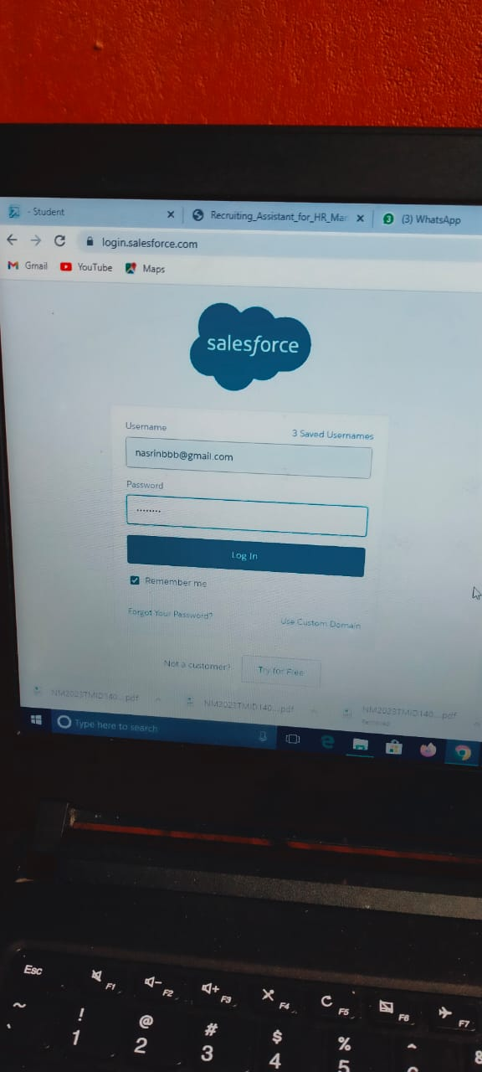  
Milestone 2: Creation of Object Job Posting sites & Reviews.

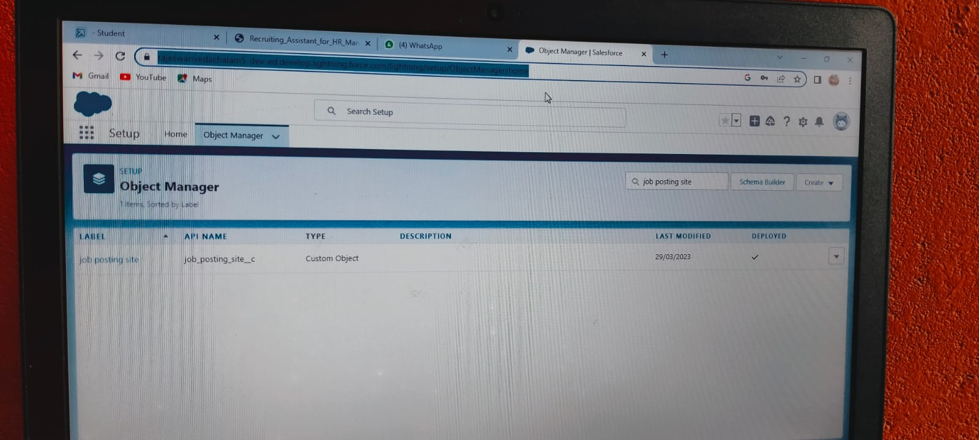

Milestone 3: Creation of Lightning App for HR Management.

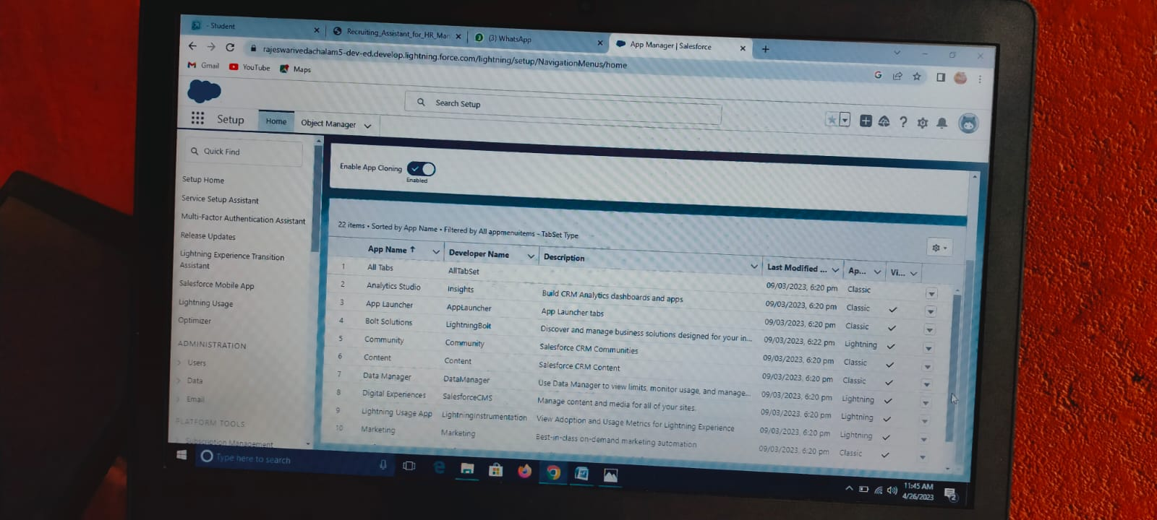

Milestone 4: Creation the fields for Job Posting sites & Reviews.

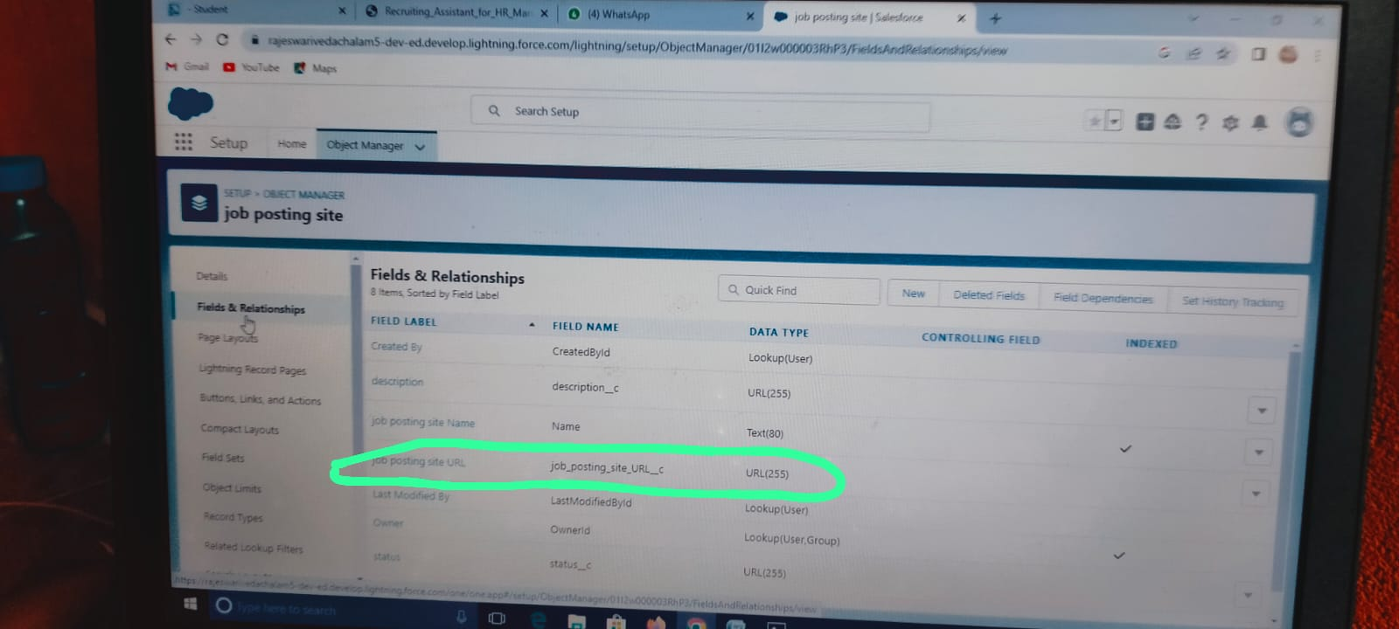

Milestone 5: Creation of Profile.

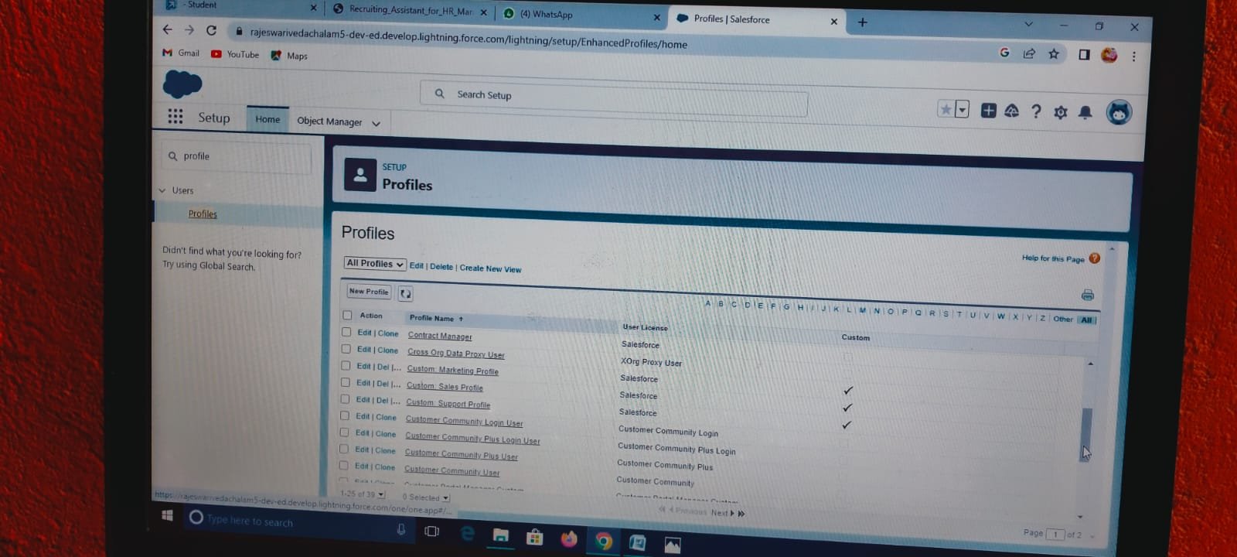

Milestone 6: Creation of User.

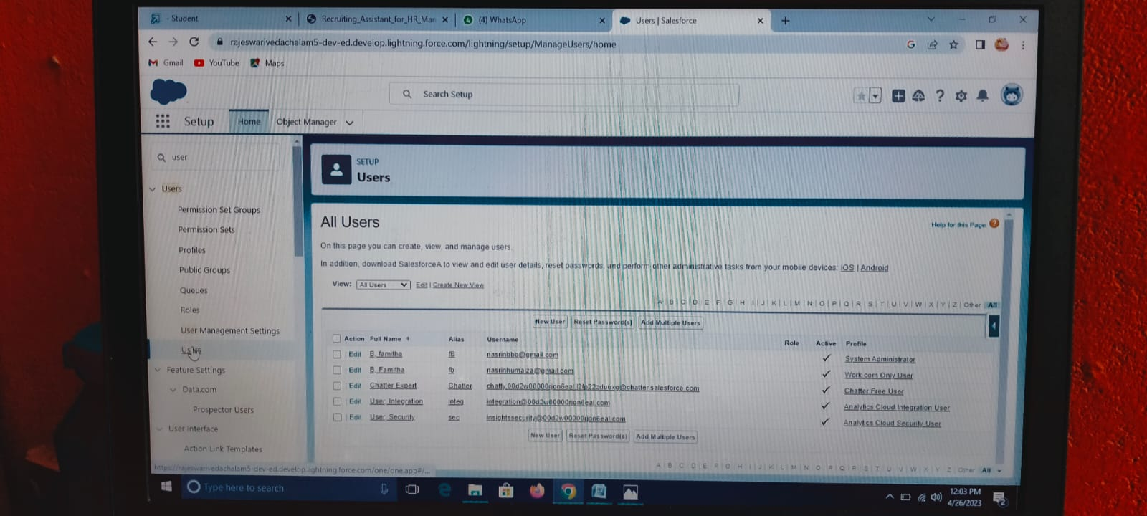

Milestone 7: Creation of Permission Sets.

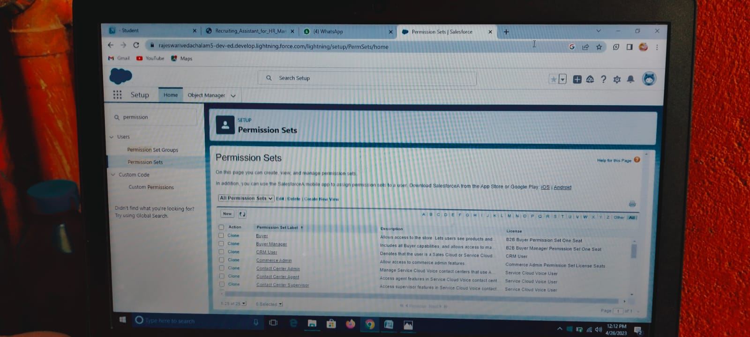

Milestone 8: Creation of Reports.

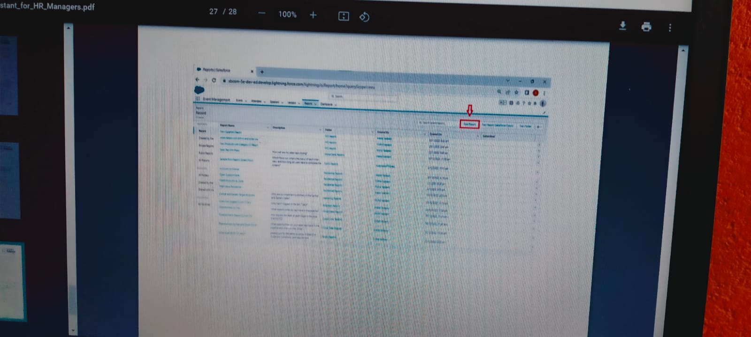

4.Trailhead profile public URL:

Team Leader : https://trailblazer.me/id/nnandhini21

Team member 1: https://trailblazer.me/id/famib

Team member 2: https://trailblazer.me/id/ddevi196

Team member 3: https://trailblazer.me/id/janas71

# 5. Advantages and Disadvantages :

In this salesforce we are prepare a HR Management app for job application and guided TL members. And it is very useful to easily take over the level of gathering BIO-DATA and Etc….

# 4.APPLICATION :

Our Apps is to be :

* All kinds of HR Management,
* All type of Report collecting Companies,
* Etc……

# 5. conclusion :

We are create the objects with the help of Job Application and guided TL members with the help of salesforce app. And also create app (HR Management)with the help of salesforce . And then the objects are converted to field and then permission sets. Atlast finished the creation of App.

# 6. Future Scope:

Ability to create a App.